The Cancer’s Metastasis: A Possible Mechanism ?
Rolland R CONTE

Thursday, April 15, 2010

What can be generally said?
Metastasis (Greek: from methistanai, to change, displacement, plural: metastases), or metastatic disease, sometimes abbreviated “mets”, is the spread of a disease from one organ or part to another non-adjacent organ or part. It had been previously thought that only malignant tumor cells and infections have the capacity to metastasize; however, this is being reconsidered due to new research.
Cancer metastasis remains a mystery to modern medicine
Cancer cells can break away, leak, or spill from a primary tumor, enter lymphatic and blood vessels, circulate through the bloodstream (circulating tumor cells), and be deposited within normal tissue elsewhere in the body. Metastasis is one of three hallmarks of malignancy (contrast benign tumors). Most tumors and other neoplasms can metastasize, although in varying degrees (e.g., glioma and basal cell carcinoma rarely metastasize).
When tumor cells metastasize, the new tumor is called a secondary or metastatic tumor, and its cells are like those in the original tumor. This means, for example, that, if breast cancer metastasizes to the lungs, the secondary tumor is made up of abnormal breast cells, not of abnormal lung cells. The tumor in the lung is then called metastatic breast cancer, not lung cancer.

Modes and sites of metastatic dispersal.
Metastatic tumors are very common in the late stages of cancer. The spread of metastases may occur via the blood or the lymphatics or through both routes. The most common places for the metastases to occur are the lungs, liver, brain, and the bones. There is also a propensity for certain tumors to seed in particular organs. This was first discussed as the "seed and soil" theory by Stephen Paget over a century ago in 1889.
For example, prostate cancer usually metastasizes to the bones.
In a similar manner, colon cancer has a tendency to metastasize to the liver.
Stomach cancer often metastasizes to the ovary in women, then it is called a Krukenberg tumor.
According to the "seed and soil" theory. it is difficult for cancer cells to survive outside their region of origin, so in order to metastasize they must find a location with similar characteristics. In 1928 James Ewing challenged the "seed and soil" theory and proposed that metastasis occurs purely by anatomic and mechanical routes.
For example, breast tumor cells, which gather calcium ions from breast milk, metastasize to bone tissue, where they can gather calcium ions from bone. Malignant melanoma spreads to the brain, presumably because neural tissue and melanocytes arise from the same cell line in the embryo.

Cancer cells may spread to lymph nodes (regional lymph nodes) near the primary tumor. This is called nodal involvement, positive nodes, or regional disease. ("Positive nodes" is a term that would be used by medical specialists to describe a patient's condition, meaning that the patient's lymph nodes near the primary tumor tested positive for malignancy. It is common medical practice to test by biopsy at least two lymph nodes near a tumor site when doing surgery to examine or remove a tumor.) Localized spread to regional lymph nodes near the primary tumor is not normally counted as metastasis, although this is a sign of worse prognosis. Transport through lymphatics is the most common pathway for the initial dissemination of carcinomas.

In addition to the above routes, metastasis may occur by direct seeding, called transcoelomic spread, a route of tumour metastasis across a body cavity. This is generally only seen in the peritoneal or pleural cavities by ovarian tumours and mesotheliomas respectively. Transcoelomic spread commonly occurs in advanced cancers of the lung, stomach, colon, ovary, and endometrium.

Diagnosis and Monitoring of Metastases

Some primary cancers, such as lung and ovarian cancers, begin to shed tumor cells that form metastases elsewhere in the body before the primary cancer is large enough to be detected by standard diagnostic techniques. Marker molecules that are given off by micrometastases circulating in the bloodstream can now be detected.

Tumor markers are substances produced either by tumors themselves or by the body in response to a tumor. The blood levels of tumor markers can be used to evaluate the recurrence or spread of cancer and the patient's response to treatment. Some commonly used tumor markers include: prostate-specific antigen (PSA) for prostate cancer; prostatic acid phosphatase (PAP) for prostate cancer that has metastasized, testicular cancer and leukemia; and CA 125 (Cancer antigen 125) for recurrence of ovarian cancer. It also detects cancers of the uterus, liver, pancreas, colon, cervix, lung, and digestive tract, as well as several others.

DNA analysis can be used to distinguish metastatic tumors from multicentric tumors. A multicentric cancer is one that appears simultaneously in several different parts of the body, as distinct from cancers with primary and secondary (metastatic) tumors. Mutations in the p53 tumor suppressor gene have been used as "genetic fingerprints" to identify differences between multicentric and metastatic tumors.

Alternative and Complementary Therapies

The National Center for Complementary and Alternative Medicine (NCCAM) is sponsoring new as well as ongoing trials of alternative treatments for metastatic cancer. One ongoing trial involves PC-SPES, a combination of eight Chinese herbs that is used to treat prostate cancer. Other trials are evaluating the use of herbal remedies to treat the side effects of chemotherapy. The National Cancer Institute (NCI) makes information about ongoing clinical trials available.

What the Theory of High Dilutions might bring?

The Whites Holes in the Foundation of the THD
The Starting idea:
If for Einstein the starting hypothesis was “the gravitation distort the space time”, our original hypothesis was even more provocative:

In the Hahnemann step wise dilution process at each step some part of the molecules goes to the drain, but must leaves behind its wave form!

We called it a white hole

This hypothesis was logical since the reality clearly indicated the effect of these dilutions. However this simple idea was a shocking hypothesis since there is a dualism between, matter and light and nobody could dream, even today, to split them.
With our new mathematics, we could write such behavior in relativistic quantum fields in physics.
The key was to introduce a “singularity in the space time” like the distortion by the gravitation.

The use of our new statistical tool “the contonian statistic” allows to do the full interpretation of the NMR measurements who are chaotic in appearance.

The interaction of a diluant’s proton with a white hole (thanks to the shaking) gives birth to hyper protons who after materialization will give the Beta (-) or Electron.

From THD page 54:
… Therefore, the theoretical basis of reaction diagrams between a White Hole and matter leads to the statement, according to the classical relation, that:
A White Hole gives: an Hyperproton + a virtual electron + an anti-graviton
according to the rules of fractional equality of the mass-energy and charges.
From this relation, we can assume the relations presented in Figure 3-13, which are verified all along this work by the Beta emissions and the effects of gravitation put forward, in accordance with our theoretical model (which includes the classical model).
The materialization-dematerialization is regulated by gravitons. We noted that time doesn't appear as a variable, the F(x, y, z) variations of gravitation defining the time.
This is the essence of our work anticipated by nobody else in the world I still feel that could be a difficult step to be so easily accepted because the novelty in the idea and the new mathematics. That does not imply that the outcome should be ignored or evaluated as a joke.
Hahnemann favorite saying: what can be observed really must be at least possible

Measuring the Beta Spectrum
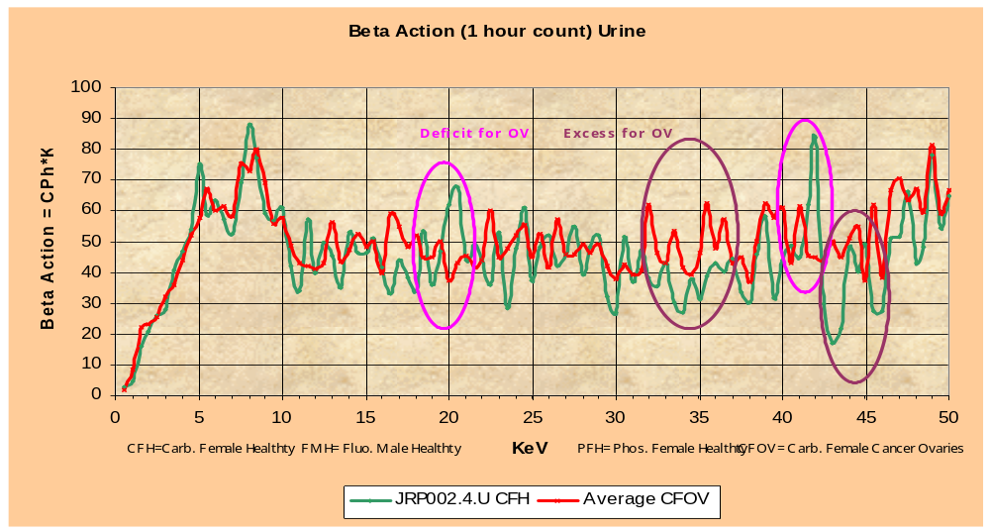Figure 1: Beta spectrum for carbonic woman (CFH= Health and CFOV= Ovarian Cancer)
The action is calculated as the count time its energy level.
If count=6 at 10 KeV, action is 6*10=60.

In physics, action is an attribute of the dynamics of a physical system. It is a functional which takes the trajectory (also called path or history) of the system as its argument and returns a real number as the result.
It has units of energy × time (joule-seconds in SI units). Planck's constant is the quantum of action.

Generally, the action takes different values for different paths. Classical mechanics postulates that the path actually followed by a real physical system is that for which the action is minimized (or, more strictly, is stationary). The classical (differential) equations of motion of a system can be derived from this principle of least action.

The stationary action formulation of classical mechanics extends readily to quantum mechanics in the Feynman path integral formulation, where a physical system follows simultaneously all possible paths with amplitudes determined by the action. It also provides a basis for the development of string theory.

If the action is represented as an integral over time, taken along the path of the system between the initial time and the final time of the development of the system,

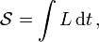
the integrand, , is called the Lagrangian. For the action integral to be well defined the trajectory has to be bounded in time and space.

Figure 2 : Lagrangian of Beta spectrum for carbonic woman (CFH= Health and CFOV= Ovarian Cancer)
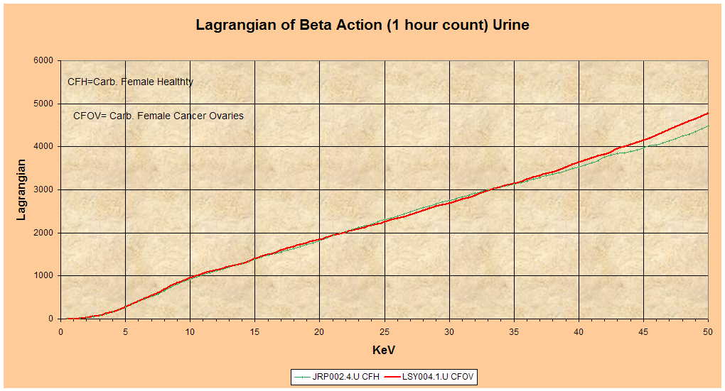
It require more action for ovaries cancer than the healthy state.
Therefore for the same food energy intake the patient will loose weight.

The use of multivariate analysis would present with more detail what is the difference between these two spectra like presented in figure 3.

Figure 3: Multivariate analysis for carbonic woman (CFH= Health and CFOV= Ovarian Cancer)

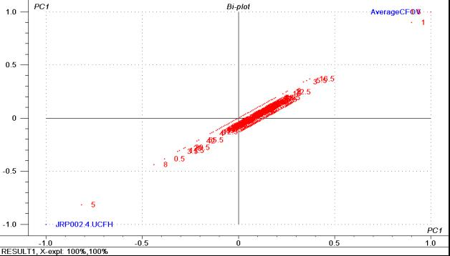

Does electromagnetic signal been measured by others?

Yes in 2009 by Dr Montagnier and al.
Abstract of their communication:
A novel property of DNA is described: the capacity of some bacterial DNA sequences to induce electromagnetic waves at high aqueous dilutions. It appears to be a resonance phenomenon triggered by the ambient electromagnetic background of very low frequency waves. The genomic DNA of most pathogenic bacteria contains sequences which are able to generate such signals. This opens the way to the development of highly sensitive detection system for chronic bacterial infections in human and animal diseases.

Yes in 1999 Vladimir Voeikov, Ph.D. published: The Scientific Basis of the New Biological Paradigm.
The stable non-equilibrium that characterizes living processes belies the reductionist view of biology today, and leads the way to a real understanding of biological processes, beyond the Second Law of Thermodynamics.
“A living System Is As Hot As the Sun”
The non-equilibrium of a living system should be displayed at all levels of its organization. So, at the temperatures characteristic of the existence of life, the maximally non-equilibrium state of molecules is the state of their maximum electronic excitation. Transition of an excited molecule to a ground state is accompanied by photon (light) emission. in 1923, Gurwitsch discovered that living organisms emit photons in the ultraviolet (UV) range of the spectrum (very high energy photons). The intensive studies in many laboratories subsequently showed that nearly all cells, tissues, and organisms are capable of emitting such radiation, and that UV photons are a prerequisite factor for induction of cellular division (mitosis). Gurwitsch thus defined such emission as mitogenetic radiation.
The intensity of spontaneous mitogenetic radiation is extremely low. In addition to this type of radiation, however, in response to multiple external factors, all living systems emit a considerably more intense photon flux in the UV as well as in the visible part of the spectrum.

Gurwitsch’s Famous Onion Experiment
Figure 4 : Gurwitsch’s experiment
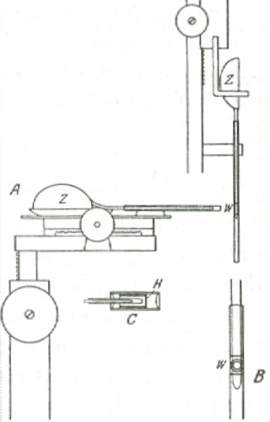
The cells at the root tip of a growing onion divide quickly. During growth, the circular cross-section, characteristic of the whole root, is maintained. Although individual cell divisions appear to occur in an unordered, even random distribution, the number of divisions in all directions from the axis must nevertheless be approximately equal. The root would otherwise not have a cylindrical form.
Gurwitsch supposed that at least some of the cells must be emitting light that regulated the rate of division of the other cells; he proved it by means of the experimental set-up shown here, figure 4. The roots (W) of two onions (Z) were positioned perpendicularly, so that the tip of one root pointed to one side of the other root. He then examined under the microscope the second root, at the site facing the tip of the first root. He was able to establish a statistically significant increase in cell divisions there, compared to the opposite, "unirradiated" side. This effect disappeared when he placed a thin piece of window glass between the two roots, and it reappeared when he replaced the window glass with quartz glass! That meant that ordinary glass is opaque for mitogenetic radiation, while quartz glass is translucent. Hence electromagnetic radiation must be operative, and ultraviolet light in particular, since it passes through quartz, but is stopped by window glass.

The Beta activity of the bean’s growth

Beans’ samples are counted in a Beta counter TRICARB 2300 TR from Packard Instrument, single PM counting, radiations coming from North. Living matter is materialized by its beta activity expressed in Counts-Per-Minute (CPM). CPM quantify the various steps of the bean’s germination. Though the lack of water on beans induces a decreasing of their weight, it doesn’t affect their CPM counting.
As illustrated by figure 5: The living matter still exists and there is only a slowdown of the growth when the bean is short of water (7th to 9th days).
The cotyledon is only a food stock (CPM of the cotyledon is nearly constant) so that the radicle can grow.
Figure 5 : Beta activity of the bean during its germination
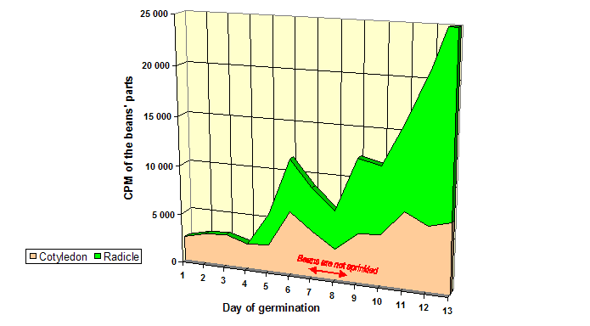

(Variety Primanor planted on 21-Jul-97 in Lyon-France, 262 CPM for 2 ml of Elga water)

Over view of the electromagnetic spectrum

Figure 6: Location of the UV and the Beta
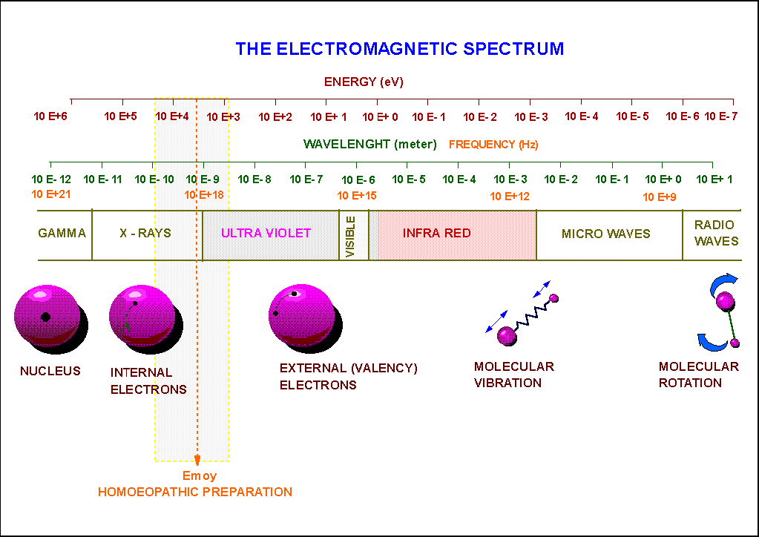
This figure 6 is a qualitative vision of the respective energy range in which the nucleus, internal electrons (layers k, l, m) are located.

Within the electromagnetic spectrum, the beta or electrons we refer to are located between the layer m (the outside of the internal electronic structure) and the valancy electrons. They are called 4th electronic layer or free electrons. Their energy lies in the range of 1 and 60 KeV.
Note: They are on the average located at the transition interface between the UV and the X-rays.
It is well known that a change in the electronic structure as a whole will induce changes in physical and chemical properties

These previously unknown free electrons in homoeopathic dilutions (figure 7) as well as in living thing (animal, plants, humans) are the discovery of the Authors of The Theory of High Dilutions.

Figure 7: Beta Spectrum of high dilutions Multivariate Analysis
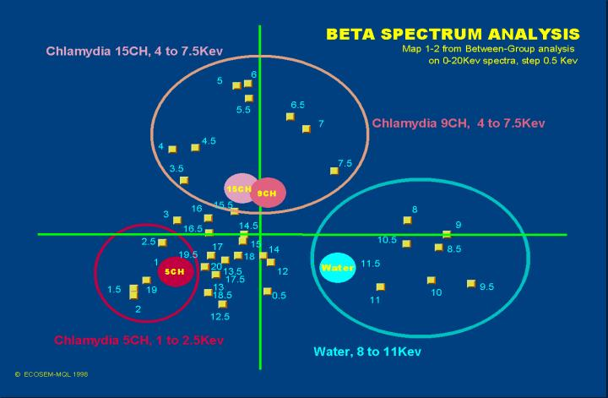

Possible mechanism leading to metastases

When tumor cells metastasize, the new tumor is called a secondary or metastatic tumor, and its cells are like those in the original tumor.
When primary cancer cells are “destroyed” by chemio therapy their Beta spectrum remains and materialize in another organ. To avoid such proliferation and the re-structuration of the beta spectrum of an healthy organism, the use of high dilution could be an interesting approach. Figure 8 illustrate an “in vitro” process.
Figure 8: In vitro simulation of a possible cancer’s therapy
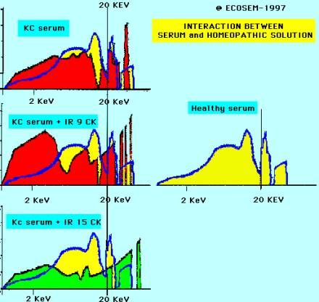
At 9CK dilution level, the KC spectrum has been modified but not yet identical to the healthy serum in yellow.
The objective now is to see how the addition of a high dilution of a given molecule called IR will modify the KC serum to look like the reference pattern of a healthy subject.
At 15CK the peaks in the spectrum corresponding to high energy electrons are almost completely eliminated and the spectrum resembles more closely that derived from a healthy subject.

This is a powerful and easy method to select and optimize products, dilution level, quantity for the return of a subject to the healthy state.

Summary
The Theory of High Dilutions has brought into evidence the following:

An equation to describe the action of the dilution and succussion process and insert the high dilution properties into the corpus of science. From the equation you expect an impact of the gravitation force on homoeopathic solutions and the alive organism.

A method (nmr, beta counter) of measuring the changes brought about by dilution and succussion.

A mathematical tool which allows the interpretation of the above changes and allow the appraisal of the reproducibility of the experiments.

Physical verification that the properties of high dilutions are different to those found in the diluent.

The discovery of beta radiation (free electrons) in homoeopathic preparations.

Evidence of the existence of the beta radiation (free electrons) in alive systems (animals, plants…)

A model of how homoeopathic remedies interact with the organism through reorganization of the beta spectrum.

Beta spectrum may be used as a fingerprint of health state in diagnosis.

http://en.wikipedia.org/wiki/Metastasis
http://www.mesotheliomaweb.org/metastasis.htm
http://www.answers.com/topic/metastasis
http://nccam.nih.gov/
http://www.cancer.gov/
http://www.high-dilutions.net
From THD 2, page 18: …To formulate the notion of White Hole, we need to consider the Quantum Theory of relativist fields, indeed this notion contains quantum sides - fields - and relativist sides - cone of the future -. The idea is that a discontinuity of the Space-Time induces a wave, which usually is considered in astrophysics as "black holes" (which have an infinite density). But in biology, the singularities to consider are those of the "White Hole" (with no matter density). We are going to give the equation of a White Hole in relativist Quantum Theory, and then the equation of an "Hyperproton" which will be the superposing of a White Hole and a proton (which is the heaviest simple charged particle). The White Hole will appear, when alone, as being non-charged and inducing a neutronic type field. To provide the equations of a field in quantum Theory, only the Lagrangian needs to be given, then the chronological products will be given by the "Measure of Feynman" and totally define the field. Technical problems are involved in the exhibition of the Measure of Feynman, but we have seen in the Theory of the Ethers that this measure can be defined as the measure of Von Neumann on an ether. The Lagrangian of a White Hole is the Lagrangian from which derive the following equation: 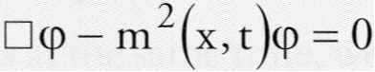
http://en.wikipedia.org/wiki/Action_(physics)
CAMO Software AS Nedre Vollgate 8, N-0158 OSLO, Norway Phone: (+47) 22 39 63 00 Fax: (+47) 22 39 63 22 E-mail: unscrambler@camo.no Web: http://www.camo.no
Luc MONTAGNIER , Jamal AISSA, Stephane FERRIS, Jean-Luc MONTAGNIER, Claude LAVALLEE Electromagnetic Signals Are Produced by Aqueous Nanostructures Derived from Bacterial DNA Sequences Interdiscip Sci Comput Life Sci (2009) 1: 81–90 DOI: 10.1007/s12539-009-0036-7
Vladimir Voeikov in 21st CENTURY Summer 1999, pp 18-33
Gurwitsch A.G. Das Problem der Zellteilung (the problem of Cell division) 1926

